Slate Cheat Sheet

Table of Contents

Tabs Cheat Sheet 3

Dashboard 3

Timeline 3

Application(s) 3

Profile 3

Materials (work in progress) 3

Recruitment 3

Search Bar Cheat Sheet 3

Interactions 4

Calendaring 4

Trips 4

Adding events to trips 5

Flights within Trips 5

Events 5

High School Visits 5

Exporting from Slate to Outlook 6

Scheduler 6

Coffee with a Coug 6

Emailing 7

Setting up Slate Gateway 7

Manually Linking to Slate Gateway 8

Texting 8

Query Cheat Sheet 8

Codes and Subcodes Cheat Sheet 8

How do I….? 9

Add an inquiry card? 9

Add a new student record (from an email, phone call, etc.)? 10

Add a high school/transfer counselor? 10

Log a new interaction with a student? 10

Cancel a student? 10

# Tabs Cheat Sheet

## Dashboard

* Entry term
* Campus(es)
* Academic Interests
* Pullman Recruiter

## Timeline

Shows all interactions a student has had with the university. Will not show post-dated items.

* Communication history
* You can click on the highlighted link to see more information, like an email we sent.
* You can also resent communication emails from here!

## Application(s)

## Profile

* Biographical
  + Editable form to update name/DOB/citizenship status
* Contact/Address
  + All addresses including phone numbers, email addresses, etc.
* Relationships
  + Pulls from the application itself
* Schools
  + Includes dates of attendance
* Scores
  + Includes all scores and differentiates verified versus self-reported

## Materials (work in progress)

* Application data

## 20XX UGRAD

* Applicant = application, no decision
* Admitted = admitted
* Prematriculant = prematric
* Active in program = confirmed

## Recruitment

* WSU student ID
* WSU Network ID
* Orientation Session
* Housing status (waived versus applied)
* Housing application date
* Opted in for texting

# Search Bar Cheat Sheet

The search bar is universal and can be searched on any of the following:

* First name, last name (any order and no common necessary)
* Email address
* WSU student ID number
* Phone number
  + Pro Tip: You HAVE to use a leading 1 to search for a phone number. If you search my cell using just 5098605988 it won’t show my record, but typing in 15098605988 will.

If you recently searched for a student and can’t remember who they are, you can click “Records” then “Recents” to see the last ten records/queries/etc. that you’ve searched for.

# Interactions

After an event is logged into the calendar (see tab below), you can bulk add attendees. In this example we will bulk add an interaction of “High School Visit” attendee to students.

1. Pull up the event that you want to log attendees for.
2. Click “new registrant”
3. Under “search registrants” (see below) search for the student you want to add and click on them. Update their registration with any new information (if applicable). Click submit.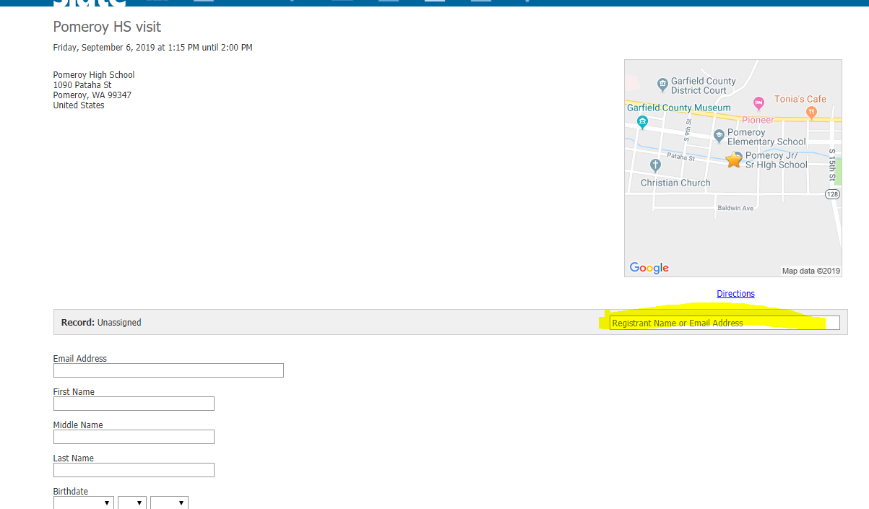
4. If the student isn’t found when you search for them, manually fill out the information there. Click submit.
5. Click “Launch Check In”
6. Check boxes next to all applicants.
7. Click “Conclude Event” link

# Calendaring

We will be using the Slate “Trips” and “Events” calendars in place of Trumba. Here are the instructions (in order) of how to create your new calendar within the application.

## Trips

1. Click “Trips” under the calendar icon
2. Click “New Trip”
3. Name the trip with the location and travel timeframe (I.e. Arizona Fall 2019, Everett Fall 2019, etc.). Click save.
   1. This is your over-arching calendar. Unless you have multiple, very different territories (i.e. Northern California and Las Vegas) you will only have one “trip” but with multiple events on it. Unless/until I come up with a better way to organize the calendar this is the best way to make it “clean.”

### Adding events to trips

1. Click “New Event” in the top right-hand corner
2. Under “Page Title” include the name of the event.
3. For template, select “Pullman Recruiter Events”
4. For folder, select Pullman and then the type of visit you’re hosting (e.g. high school visit, college fair, transfer fair, etc.)
5. Choose a status (confirmed, tentative, etc.)
6. Input date and time (pro tip: double clicking the date will add it to both start and end time)
7. In the location tab, input the location (pro tip: the “Location Name” section allows you to choose not only high schools and colleges but popular locations such as Convention Centers.)
   1. Be sure that when selecting a high school to use one from the “Dataset” heading. This links it to a CEEB code and allows the automated emails to go out. Selecting from “Other Results” does not.
8. Click save.
9. Continue adding events to this trip as long as you’d like to 😊

### Flights within Trips

Additional “stops” such as flights, hotels, etc. can be added to each trip. Follow these instructions to add a flight specifically.

1. With your flight selected, add “New Stop”
2. As “Type” select flight
3. Enter all relevant information.
   1. Pro tip: Delta is DL, Alaska is ASA
4. Click save

## Events

This tab is for seeing not only your Trips but for seeing registrants for large events (FCED, FCOD, etc.) and daily campus tours. To view a registrant:

1. Select “Events” under the calendar icon
2. Select the large group event you would like to add/edit a registrant for.
   1. You will likely need to switch the folder you’re looking at.
3. Here you can click “new registration” (a blue hyperlink towards mid-page) to register someone new or edit a registrant’s information if they typed something in incorrectly

### High School Visits

As you put events into the recruitment calendar you’ll be automatically setting up a high school visit email to go out. Three days prior to the event, students at the high school will receive an email announcing your visit and inviting them to join you. As long as you’ve made the event “confirmed” and chosen a location that has a CEEB code attached the email will be going to students who list that school as their “School 1.”

1. Using the instructions under “adding events to trips,” enter in all your high school visits into the appropriate calendar and trip
2. Three days prior to your visit students will receive an automated email with the visit’s date and time asking them to attend.
3. After the visit has concluded, follow the instructions under “interactions” to log who attended.
4. An automated email will go to all students who attended the visit thanking them for coming and inviting them to follow up with any questions.

## Exporting from Slate to Outlook

1. Select “Events” under the calendar icon
2. On the right-hand side like “Your Events” under the “iCal Subscribe” header

## Slate.org Events

Slate.org is the Slate interface for high schools and CBOs. It’s free to use for those schools and they’re able to create events and invite Slate colleges to attend those events. It functions a bit like Rep Visits, Scoir, or Maia does in helping reduce the back and forth emailing/calls of booking events.

1. Select “Slate.org” under the calendar icon
2. From here you can see an event you’ve been invited for or search for events that you’d like to attend.
3. In the search bar, type in the name of the school you want to attend or the city that you’re travelling to.
4. Click on the event you’d like to attend and click “request registration”
   1. There are multiple tabs on each event that you can look through. Be sure to check the “description” tab for further instructions
5. Once the event is confirmed you can add it to a trip as an event!

# Scheduler

## Coffee with a Coug

We will be using scheduler to setup appointments students can sign up for when we are hosting Coffee with a Coug. You can view where students register at: <https://futurecoug.wsu.edu/portal/coffee>

How to setup a scheduler event:

1. Go to “Scheduler” (the calendar with the clock symbol)
2. Select “New Slot” on top left
3. Fill out the form. For the “Page Title” put the city/location your event will be hosted at:
   1. 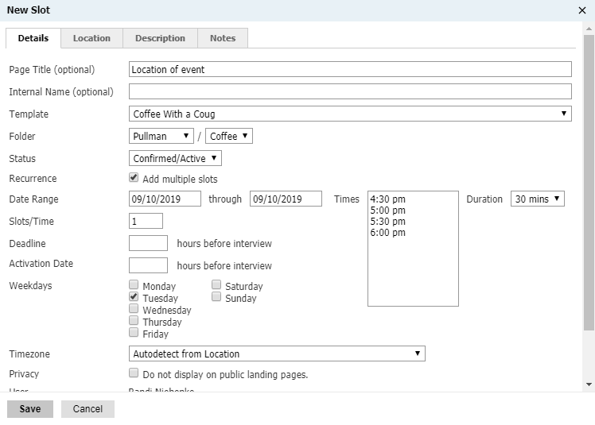 Once your event is ready and you know days and times, make sure put confirmed/active. If it is left as “tentative” it will not show on the website and students cannot register.
   2. When you scroll down you can also add a “trip” so it will be included with your fall travel schedule.
   3. You will also want to add your email to “admin notify email” so you will receive an email when a student registers.
4. On the location tab, you will want to search for the location/address you will be meeting students
5. Once your form has been completed, hit save and registration is now live for your event.

# Deliver

1. Click on deliver
2. New Mailing
3. Give it a name
4. Assign a folder, realm, etc.
5. Choose the method of communication you plan to send out (email, text, etc.)
6. Choose if you want them to be able to opt-out and if so what they’d like to unsubscribe from
7. Choose if you want UTM tracking. Check this if you want to see how students are opening your delivery, if they’re clicking on things, etc.
8. Click “edit recipient lists”
   1. You can now either upload a spreadsheet or build a query
   2. To build a new query, give it a name and build it like a standard query. See query section for details ☺ Hint: pick Slate Template Library and Prospects & Applicants for most all queries that you’ll be building as an Admissions Counselor.
   3. The big difference between building a standard query and building a deliver campaign is the export section is also the merge field section. This means you’ll want to be sure to include fields such as the student’s email, phone number, etc.
9. Click “edit message” to create the message that you want sent out.
10. Click send mailing once you’ve completed the above and know when you want it sent out!

# Emailing

## Setting up Slate Gateway

BCCing your Slate Gateway email address in an email will automatically add it to a student’s record.  By adding the private email address below to your address book in outlook, you can quickly add messages exchanged outside of Slate to the appropriate records in Slate. To forward a message that you have received into Slate, you can either BCC this address on your reply or forward the message to this address. Keep this address private and do not include it in the 'To' or 'CC' lines when replying to a student. Messages received by this gateway will typically be added to the records within 15 minutes of receipt. To get your Slate Gateway address:

* Click Database
* Under the Messages column, click “Email to Slate Gateway”
* Add the email address to your contacts list.
* Be sure to BCC or forward the email to the address for every student/parent that you speak with

## Manually Linking to Slate Gateway

Not every email will link up on the first try with Slate Gateway. To remedy this you’ll need to clean out your Gateway Inbox weekly. To do this:

1. Click the Deliver icon
2. Click “Gateway Inbox”
3. Click the email you’d like to link
4. Choose an assignee from either the list provided or by manually searching for the student’s record
5. Click “assign”

# Texting

Using your phone number (509-553-XXXX) students/parents can text you and this will also automatically link with their student record. To view/respond to texts:

* + - 1. Click Inbox
      2. Click “Your Assignments”

# Query Cheat Sheet

When you first create a query and click on “exports” or “filters” it’s a good idea to click on “edit pinned” and save all of your query basics there (first name, last name, birth date, ID number, etc.) to make building queries quicker in the future. You can then pick “select all” when you get to the export section on future queries and update as necessary. This can be done for both exports and filters individually.

|  |  |
| --- | --- |
| **What you select** | **What you get** |
| Name | Last Name, First Name |
| Preferred | Nickname |
| First | First Name |
| Assigned Recruiter Pullman | AC |
| Region | State |
| Round | Year and student type (e.g. 2020UGRAD) |

# Codes and Subcodes Cheat Sheet

|  |  |  |
| --- | --- | --- |
| **Code** | **Subcode** | **When to use** |
| Appointment |  | During a CWAC meeting, private meeting, etc. |
| Email | Email Direct to Parent | When NOT using your Slate email to add a comm history with a parent |
| Email | Email Direct to Student | When NOT using your Slate email to add a comm history with a student |
| Event Attendance | Reception Attendance | When a student attends a reception |
| Event Attendance | Transfer Event Attendance | When a attends a transfer event |
| Event Registration | Reception Registration | When a student registers for a reception |
| Handwritten | General Handwritten Card | General card—not grad/top scholar/etc. |
| Handwritten | Graduation Handwritten Card | Grad Card |
| Handwritten | Holiday Handwritten Card | Holiday Card |
| Handwritten | Top Scholars Handwritten Card | TS card |
| Phone Call | Admit Service to Student | When assigned a call project |
| Phone Call | Call Direct to Parent | Parent call out/in |
| Phone Call | Call to Admissions | Call in/out from TC Center |
| Phone Call | Call to Student | Call in/out directly to student |
| Phone Call | Event Followup to Student | When assigned to call students after an event/tour/etc. |
| Phone Call | Event Invitation Call to Student | When assigned to invite students to visit events |
| Phone Call | Incomplete Application Call to Student | When assigned to call students about missing items |
| Recruiter Initiated | College Fair Visit | College fairs NOT including -ACACs |
| Recruiter Initiated | Community College Visit | CC visit |
| Recruiter Initiated | High School Visit | High school visit, NOT fair |
| Recruiter Initiated | NACAC Fair Visit | NACAC attendee |
| Recruiter Initiated | PNACAC Fair Visit | PNACAC attendee |
| Recruiter Initiated | WACAC Fair Visit | WACAC attendee |
| Text Message | Text to Student | When sending a text to students outside of Slate |

# How do I….?

## Add an inquiry card?

* Check if student is already in system (using the search bar)
  + If the student exists simply update any new information and add the communication item (i.e. high school visit, college fair, etc.)
  + If the student gave you this inquiry card at an event that’s already been added to the calendar, fill out the registration form for that event on the student’s behalf.
* If it’s a new student and they didn’t give you their card at an event on the calendar, fill out the “Pullman Card Data Entry” form
  + Click the forms folder
  + Click Pullman Card Data Entry form
  + Click “New Registration”
  + Fill out information
  + Click submit

## Add a new student record (from an email, phone call, etc.)?

* In the search bar, search the student’s name and hit ENTER if they don’t exist
* Click “New Person”
* Fill out information

## Add a high school/transfer counselor?

* In the search bar, search the name of the school you’re adding the counselor to
* Under “contacts” look for the counselor’s name and information
* If the contact information is not there, click “New Record” directly under contacts
  + This will take at least 15 minutes before you can search for that counselor’s name and have it come up in the search results of an “Organizational Contacts” search
  + In the role section be sure to include what their role is—there are multiple options and the goal is to be able to do segmented communication depending on a student’s role.

## Log a new interaction with a student?

* Search for the student you’re adding the record to
* Click on the “Timeline” tab
* Click “New Interaction”
* Under code select the type of communication
* Under subcode select the specific type of communication
* List the gist of the interaction in subject
* List a full log of the call in private comments
* Don’t select “Post to online status”
* Click save

## Cancel a student?

* Search for the student
* Click the “opt out” tag on the far right-hand side
  + It will turn dark blue once activated
* Follow regular cancellation procedures
  + Email [cancel@wsu.edu](mailto:cancel@wsu.edu)
  + Log the interaction in Slate
  + Follow up with student regarding cancellation procedures

## See if a student has applied for housing or been approved for a FLIW?

* Search for the student
* Click on their recruitment tab
* Look under “Housing Application Status”
  + Reminder: Mica enters FLIWs every Friday so these aren’t as up to date as a student’s myWSU tab will be for housing

## Add an academic interest?

* Search and pull up the student record
* Go to the Recruitment Tab
* Click on the edit button (small box with pencil in upper right corner)
* Go to the “Academic Interests – Vancouver” section
* On your keyboard, hold down the Control key and then select the academic interest area you want to add.  It is important to hold the Control Key because if you click on the academic interest area first, the new area overrides the old area.
* Click Save (floppy disk with pencil button in upper right corner)